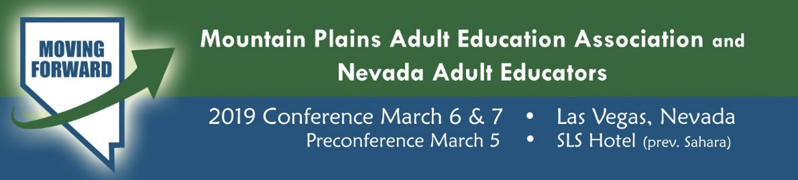
Graduate Credit Available!
Mountain Plains Adult Education Association and Nevada Adult Educators are pleased to announce that this year’s attendees will have the opportunity to register for one graduate credit (satisfactory/unsatisfactory) for a fee of only $75.
Graduate Credit Made Simple In Four Steps!
- Register for course online.
- Attend the conference and complete the conference session log.
- Write a two-page reflection paper.
- Submit the conference session log and reflection paper by April 5, 2019
To Register for Graduate Credit
Conference attendees must register for graduate credit online through Valley City State University in North Dakota
CLICK HERE for Valley City State University Registration

Class Name & Number
EDUC 2000 – MPAEA/NAE Professional Development Conference for Adult Educators (Class# 20686)
Course Requirements
Attendees must:
- Complete the MPAEA/NAE Professional Development Conference Session Log. CLICK HERE for MPAEA/NAE Session Log
- Submit a two-page (maximum) double-spaced Reflection Paper of a takeaway from the conference that you will put into practice when you return to work.
- Turn in Paperwork!
  - Session Log and Reflection Paper should be submitted as email attachments to Dr. Thomas Gravel at tmgravel@gmail.com NO LATER THAN APRIL 5, 2019
Grading and Transcripts
Students will be graded on an ‘S’ (Satisfactory)/‘U’ (Unsatisfactory) basis. Students who meet the course requirements will be awarded an “S “grade; students who do not will be awarded a “U” grade.
Grades and transcripts will be available by going to www.getmytranscript.com and choosing Valley City State University.
National Board for Professional Teaching Standards
The National Board for Professional Teaching Standards seeks to identify and recognize teachers who effectively enhance student learning and demonstrate the high level of knowledge, skills, abilities and commitments. The Five Core Propositions underscore the accomplished teacher’s commitment to advancing student achievement. Together, the propositions form the basis of all National Board Standards and the foundation for National Board Certification.
This course and conference align with Propositions One, Four, and Five
- Proposition 1: Teachers Are Committed to Students and Their Learning
- Proposition 2: Teachers Know the Subjects They Teach and How to Teach Those Subjects to Students
- Proposition 3: Teachers Are Responsible for Managing and Monitoring Student Learning
- Proposition 4: Teachers Think Systematically About Their Practice and Learn from Experience
- Proposition 5: Teachers Are Members of Learning Communities
Questions: Please contact Dr. Thomas Gravel at tmgravel@gmail.com or 701-356-2008 with any questions.

